# **TUFJORD Upholstered bed frame,**

# **Gunnared blue**

**Product details $1200**

The curved headboard is great for cozy, cocooning moments, helping you to unwind and relax in bed.

**Materials & care**

* **Fabric:**100 % polyester
* **Mid beam:** Galvanized steel
* **Bed slats:** Layer-glued wood veneer, Adhesive resin as coating
* **Headboard:** Steel, Epoxy/polyester powder coating, Plywood, Fiberboard, Paperboard (min. 0% recycled), Laminated veneer lumber, Polyurethane foam 20 kg/co., Polyester wadding
* **Bottom headboard rail:** Plywood, Laminated veneer lumber, Fiberboard, Polyester wadding
* **Footboard/ Bedside:** Plywood, Laminated veneer lumber, Fiberboard, Polyurethane foam 20 kg/co., Polyester wadding
* **Lining:**100% polypropylene
* Do not wash. Do not bleach. Do not tumble dry. Do not iron. Vacuum clean. Wipe clean with a cloth dampened in a mild cleaner.

## Product size

**Length:**

223 cm (87 3/4 ")

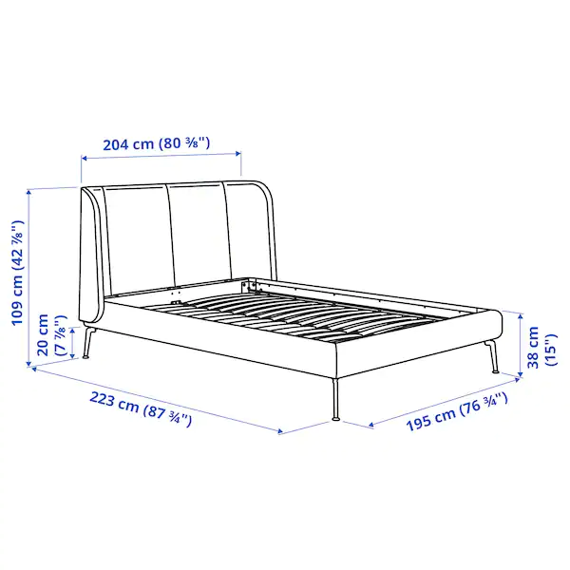**Width:**

204 cm (80 3/8 ")

**Footboard height:**

38 cm (15 ")

**Headboard height:**

109 cm (42 7/8 ")

**Mattress length:**

200 cm (78 3/4 ")

**Mattress width:**

180 cm (70 7/8 ")